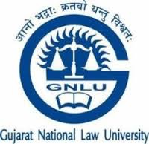

LEGAL SERVICES COMMITTEE (LSC)
ANNUAL REPORT
2017

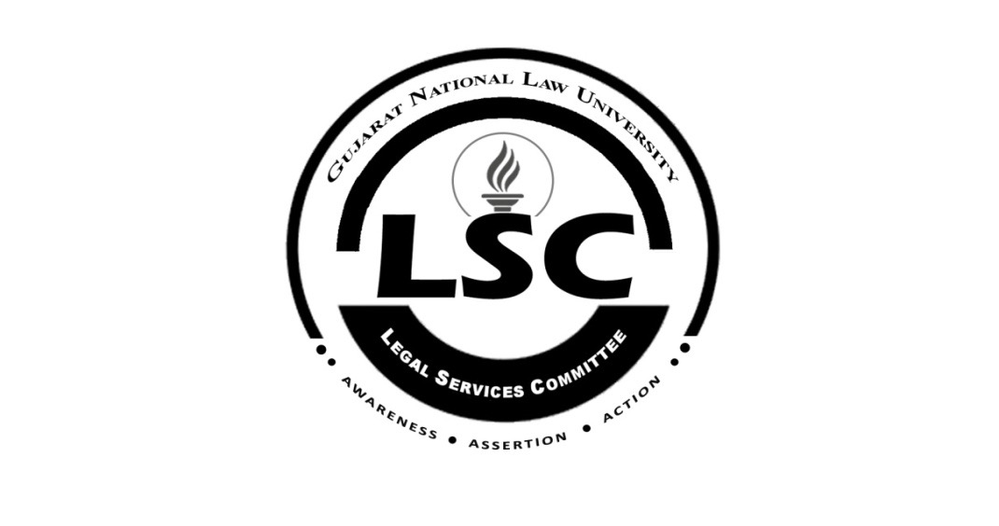

TABLE OF CONTENTS
Particulars Page No.
I. Acknowledgements 3
II. Introduction 4
III. Objectives 5
IV. Brief History 7
V. LSC Achievements in Previous Years 9
VI. Activities in 2016 17
VII. Future agendas 2017 24
ACKNOWLEDGEMENTS
We express our heartfelt gratitude to everyone who we are indebted to, for supporting us through this enriching journey and for making us who we are today, The Legal Services Committee, GNLU.
We would like to express our sincere gratitude to the High Court of Gujarat, Ahmedabad, the Gujarat State Legal Services Authority (GSLSA) and the Legal Department, Government of Gujarat for always having supported us in our endeavors and for having believed in us since our inception.
We are sincerely grateful to our former Vice Chancellor, Prof. V.S. Mani, under whose guidance this committee was established in 2007.
The dynamic and vibrant leadership of our Director Prof. (Dr.) Bimal N. Patel, whose continued efforts have helped us to further the reach of our socio-legal activities beyond the four walls of the University is also highly appreciated.
It is also imperative to express our gratitude to Mr. Saurabh Anand, Centre Director, Centre for Law and Society, Dr. Nidhi Buch, Mr. Jagdeesh Chandra, Ms. Asha Verma, Mr A.Marisport, Dr. Ambati N. Rao, Dr. Saira Gori and Ms. Palak Jagtiani for having always supported our ideas and guiding us at every step.
Last but not the least, we thank all the faculty members, student members & volunteers of the LSC, advisory members and the entire GNLU student body for having dedicated their hard work and time for our cause and having supported us in serving the society.

- Legal Services Committee, GNLU

INTRODUCTION
Gujarat National Law University (GNLU) is a University established by the Government of Gujarat under the National Law University Act, 2003. The University is recognized by the Bar Council of India (BCI) and the University Grants Commission (UGC). The institute’s founding myth exemplifies the ideals of the Rig Veda “Aa No Bhadra, Kratavo Yantu Vishwatah’ which means ‘Let noble thoughts come to us from all direction’. The GNLU fraternity aims at harmonizing these patterns of civilization, by inculcating the virtues of cultural and regional appreciation amongst the students.
The birth of the Legal Services Committee in the year 2007 is a direct result of this feeling. It was inaugurated by Hon’ble Justice A.R. Dave, the then Chairman of the Gujarat State Legal Services Authority (GSLSA). The committee is a student initiative which has achieved great laurels over the past few years. The committee takes immense pride in empowering the society with free and accessible legal aid and the spread of legal awareness. These endeavors justify the committee’s motto “Awareness, Assertion, Action”.
Recognizing the potential of law as an instrument of social change, the Legal Services Committee (LSC) runs Free Legal Aid Clinics which function as 'Community Legal Aid Clinics' and focuses on, inter alia, the lack of government benefits, eviction, issues of domestic violence, inaccessibility to basic needs like safe drinking water, sanitation and primary education. Activities like street plays, awareness programs and community legal service programs which promote legal awareness in areas concerning environment, consumer rights, human rights protection, right to information and labor laws are often organized by the LSC. Keeping in view with its objectives, LSC aims to promote a litigation free environment and encourages it with alternate dispute resolution mechanisms.
OBJECTIVES
LSC functions for the attainment of certain laid out objectives. The objectives are in tandem with the Aims & Objectives of the Legal Services Authorities Act, 1987 (hereinafter referred to as ‘the Act’). The Act was implemented in order to constitute Legal Services Authorities to provide free and competent legal services to the weaker and vulnerable sections of the society to ensure that opportunities for securing justice are not denied to any citizen by reason of economic or other disabilities, and to organize Lok Adalats to secure that the operation of the legal system promotes justice on a basis of equal opportunity.
Firstly, Section 4(k) of the Act imposes a duty on the Central Authority to collaborate with the Bar Council of India for setting up of programs for clinical legal education and promoting guidance and supervising the establishment and working of legal services clinics in universities, law colleges and other institutions. Section 8 and Section 11, respectively, state that the State Authority and the District Authority should act in coordination with other agencies like non-governmental voluntary social service institutions, universities and other bodies engaged in the work of promoting the cause of legal services to the poor.
Thus, it is imperative for the LSC to work hand in hand with the State/District Legal Services Authority for a more effective way of undertaking and acting on its pledge to help the society by creating legal awareness. Keeping this in mind the objectives of LSC are as under:
- To educate and empower the underprivileged, by conducting legal awareness programs on a wide range of issues.
- To provide the needy with free legal aid to protect and assert their rights.
- To identify the most vulnerable sections of society like women and children and work towards affording them legal protection.
- To use the legal expertise available at the disposal of the Legal Services Committee to further the cause of social development.

BRIEF HISTORY OF LSC, GNLU
The Legal Services Committee is a student body established in the year 2007. Since its inception, it has always worked in consonance with the aims and objectives of Legal Services Authorities Act, 1987. The Committee, realizing the importance of the tasks it set out to achieve, has worked with full commitment and dedication.
In its very initial years, the committee adopted Chharanagar, a village near Ahmedabad. The members used to frequently visit this village, providing legal assistance to the villagers and also conducting street plays on different issues like police atrocities, domestic violence et al. to raise awareness amongst the people.
The LSC team has always strived to contribute to the academia. In furtherance of this objective, the LSC team successfully organized a National Conference on Contemporary Corporate Legal Issues in September, 2008. This was the LSC’s First National Event and it proved to be a milestone as it witnessed the launch of “The GNLU Law Review” by Honorable Justice Radhakrishnan, the then Hon’ble Chief Justice of the High Court of Gujarat. Many dignitaries and experts of the subject shared their views with an audience consisting of law students from across the country.
In the same year, the LSC organized and conducted “Vimarsh-2008”- An Inter College Panel Discussion on Contemporary Women Issues in the university. People from different walks of life such as lawyers, journalists, academicians and social activists participated in the discussion.
The LSC members were involved in drafting the Amendment for The SC & The ST Atrocities Prevention Act which was not only an enriching experience for the students but also benefited the Gujarat Legislature.
In July 2009, based on the directions of the Hon’ble Supreme Court of India to all Universities, an Anti-Ragging Committee was set up at the University for preventing and handling ragging related complaints. This body was established on a short notice and the Legal Services Committee members became de-facto members of the Anti-Ragging Committee. The members of the committee ensured that no instances of ragging took place in the hostel and worked to provide a friendly environment to the first years. LSC worked for a month approximately till a permanent Anti-Ragging Committee was established at the University.

GNLU, being a multicultural university, has students coming from various parts of the country. Every year new students have to go through a tedious process of shifting into the hostel, transferring their luggage and arranging amenities. To assist the students in this aspect, the Legal Services Committee organized a “Fresher’s Convenience Camp” within the hostel premises to help the new entrants. The camp involved setting up of stalls which provided products and services to the students, ranging from mattresses and laptops to ATM cards and local SIM cards. This venture was found to be very useful by the first year students and the LSC received words of appreciation from the many parents who had accompanied their respective wards for the orientation. The LSC continued organizing this camp till 2010.
LSC ACHIEVEMENTS IN PREVIOUS YEARS
- The RTE Resource Center:
The LSC, in collaboration with IIM-Ahmadabad had set up an RTE Resource Center each, at GNLU and IIM-A for the implementation of Section 12 of the Right to Education Act, 2005. The team carried out extensive surveys in schools across Gandhinagar District to assess education levels and implementation of the provisions of the Act. A report was submitted to IIM-A based on these findings.

- The 2nd National Conference on Access to Justice, West Bengal National University of Juridical Sciences (WBNUJS), Kolkata 2013
The LSC attended and successfully presented a model for Prohibition of Women Trafficking in Gujarat at the 2ndNational Conference on “Access to Justice” held at WBNUJS, Kolkata. The presentation was based on an extensive research program on woman trafficking and even included a prevention model.

- Free Legal Aid Clinics
The LSC had carried out surveys in four nearby villages- Shahpur, Koba, Raisan and Kudasan- to assess the basic levels of socio-economic status and legal literacy. Free Legal Aid Clinics had been set-up in all four villages where student members, thrice every week, addressed the grievances of people. There was an overwhelming response from the villagers who turned up seeking legal remedies on contractual, land and domestic disputes.

- Free Legal Awareness:
The LSC has continued its trend of spreading free legal awareness. The members of the LSC participated in the National Service Scheme Camp in Koba organized by R.C Technical College, Sola. A series of such presentations have been scheduled for the current year as well. The following issues were addressed –
  - Fundamental Rights under the Indian Constitution.
  - FIR: Essentials and Procedures.
  - Rape: Provisions and Remedies.
  - Legal provisions relating to Domestic Violence in India
  - Provisions of the Motor Vehicles Act,1988

- Prohibition of Manual Scavenging Bill, Gujarat:
The LSC addressed the inhuman practice of manual scavenging through a workshop, following which the committee drafted certain provisions of the Manual Scavenging Bill for the state of Gujarat in 2013.

- RTIs filed for Commoners:
The LSC, based on the information provided to it by letters from villagers, filed RTIs regarding the practice of witchcraft in Koba village.

- Blood Donation Camp:
The annual Blood Donation Camp was held on 15th of September 2014, in collaboration with the Indian Red Cross Society and saw a total of 93 donations.

- Kashmir Relief Fund:
The LSC, in a first of its kind initiative, organized on September 15,2014, the Kashmir Relief Fund Campaign for the flood victims of Kashmir which saw an overwhelming response from students as well as staff.

- Blood Donation Camp 2015
Continuing its tradition forward, the LSC organized a Blood Donation Camp in the University on July 17, 2015 in collaboration with the Indian Red Cross Society, Ahmedabad Chapter. The camp was graced by the Member Secretary I/C of the Gujarat State Legal Services Committee (GSLSA) Shri. R.G. Deodhara, the Director of the Gujarat National Law University Dr. Bimal N Patel and the Registrar Dr. Thomas Matthew. The camp was a grand success, breaking all previous records and had a total of 230 student registrations and 170 resultant donations.
The Blood Donation Camp has seen a significant increase in the number of donations since the last two years as shown in the graph.
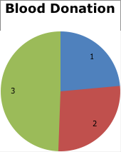

In the year 2013 there were a total of 81 donations. In 2014 the number of donations increased from 81 to 93 and in the 2015 there was a significant growth from 93 to 170.

- The 1st National GNLU Interlinking Legal Services Committee Annual Forum, October 03, 2015 to October 04, 2015
The aim of the Annual Forum was essentially to interlink all Legal Services Committees and Legal Aid Clinics of various National Law Universities and other prominent universities across the country. The Forum was a grand success and was graced by the Hon’ble Justice Mr. Mukesh Shah who was the then Executive Chairman of the Gujarat State Legal Services Authority (GSLSA).
The Forum focused on socio-legal issues of immediate importance and held interactive sessions in association with esteemed guests and experts. The sessions focused on the manner in which LSCs (and this platform to be created) could work in consonance with each other to attain social justice and equity pertaining to:
- Section 12 (1) (c) of the Right to Education Act, 2009:
Prof. Ankur Sarin, Head of the RTE- Resource Centre, IIM-A and Mr. Amitabh Shah, Founder of YUVA Unstoppable;
- Child Rights and the Law:
Ms. Anjali Shivanand, Centre for Child Rights and the Law (CCL), NLS-Bangalore, Mr. Prabhat Kumar, Save the Children;
- Women Rights and the Law:
Ms. Ranjana Kumari, Head, Centre for Social Research, Delhi, Prof. Badri Narayan, Centre for the Study of Discrimination and Exclusion, JNU, Ms. Jyotsana Yagnik, Director, United World School of Law, Ms. Chethana Desai, UNICEF, Gujarat;
- Corporate Social Responsibility:
Dr. Milind Antani, Partner, Nishith Desai Associates, Mumbai;
- LGBT Rights:
Ms. Laxmi Narayan Tripathi, Founder, Astitva Foundation, Mr. Manvendra Sinh Gohil, Prince of Rajpipla and Founder of the Lakshya Trust and Mr. Gowthaman Ranganathan, Alternative Law Forum, Bangalore.
- Drug Abuse:
Mr. Hariom Gandhi, IPS, Narcotics Control Bureau, Ahmedabad;
The Forum also saw the participation of the following organizations:
- Action Aid Society
- YUVA Unstoppable
- UNICEF Gujarat
- Alternative Law Forum, Bangalore
- Lawyer’s Collective, Mumbai
- Blind People’s Association, Ahmedabad
- RTE-Resource Center, IIM-Ahmedabad.
- Save the Children

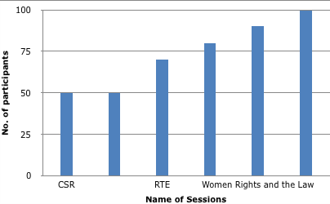

  - Participants showed interest in attending the sessions and made them quite interactive. As shown in the graph the most interesting session was on LGBT Rights whereby students were very inquisitive about the problems faced by the members of these communities and were keen to understand the problems.
- 100 Hours of Compulsory Pro-Bono Legal Service
The Gujarat National Law University (GNLU), in its endeavor to stand out as a world class university has made it compulsory from the current batch (Batch of 2015-2020) and onwards to devote 100 hours to serving the society. This endeavor is being regulated and coordinated by the LSC and performance and initiative of the students is being formally evaluated. The committee, in furtherance of its objectives, shall be responsible for the overall conduct of this endeavor.

- A Smartphone Application for basic citizen issues
The LSC, to enhance access of legal and procedural information to all, released for the first time in the history of the country, a Smartphone application so as to provide information on legal procedures and instances which are a part and parcel of our daily lives at the click of a finger. These issues range from ragging in academic institutions, traffic violations, issuance of pan cards or voter identity cards to broader issues like domestic violence and the organizational functionary to deal with it, process to procure benefits arising from government schemes and the like. The app was released at the 1st GNLU National LSC Interlinking Annual Forum, October 03, 2015 to October 04, 2015 by the Hon’ble Justice Mr. Mukesh Shah, Executive Chairman of GSLSA. The App is under review and the basic interface is being worked on.

- Play on Anti-Ragging at National Institute of Fashion Technology, Gandhinagar, July 22, 2015
The theatre wing of the LSC, better known as “Abhivyakti” performed a street play to promote an anti-ragging environment at the National Institute of Fashion Technology (NIFT), Gandhinagar for the orientation of the fresher batch of the university. The play received an overwhelming response from the audience which comprised of students, parents and faculty members of NIFT.

  - 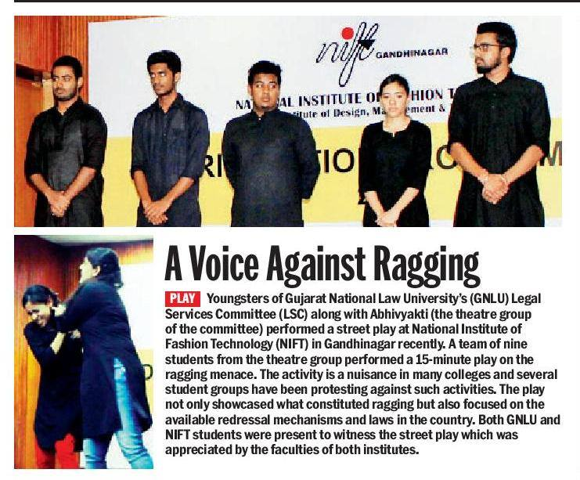

- Play on Sexual Harassment at Work-Place at GNLU, October 03,2015
Abhivyakti performed a play on the impact of sexual harassment at work place during the eve of the 1st GNLU National Interlinking Annual Forum, October 03, 2015 to October 04, 2015. The play was appreciated by the different resource persons and the students who attended the annual forum.
- Work for the cause of Pakistani Hindus
In a one of its kind initiative, the LSC on the instance of Gujarat State Legal Services Authority (GSLSA) planned to carry out a survey on the condition of life of Pakistani Hindus and more particularly, on attempting to acquire professional licenses to members of these communities who lost their licenses and practice due to migration under the law. The initial research for it was carried out. The LSC took assistance of local people living at Sadarnagar and Kubernagar in Ahmedabad and the Universal Just Action Society (UJAS), Jodhpur which is working for this cause in the country.

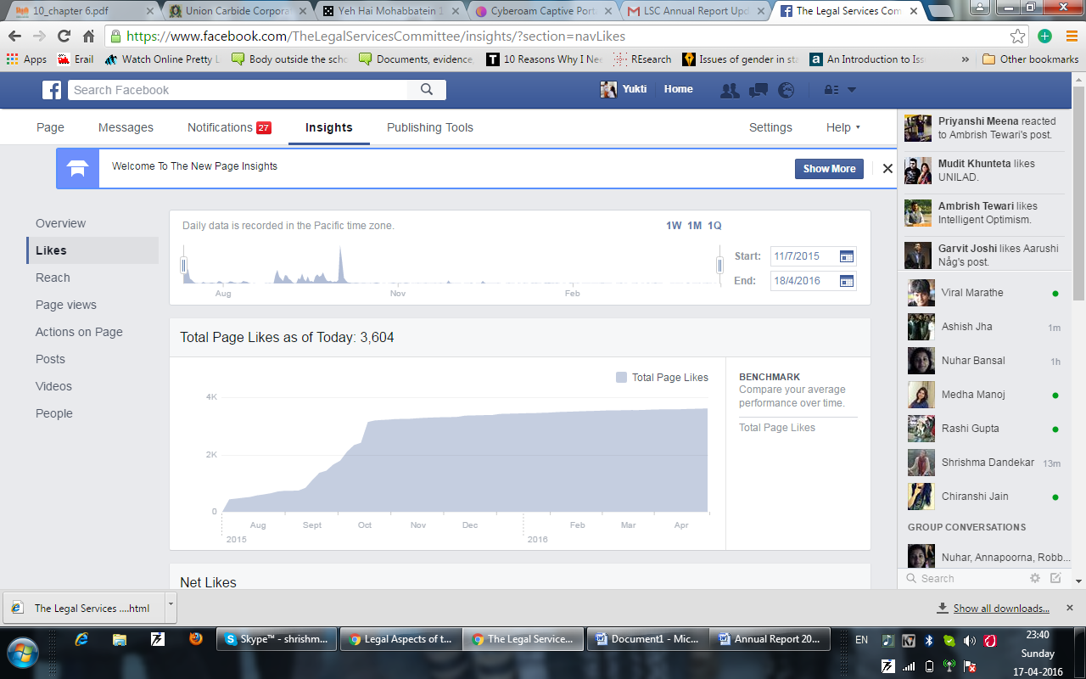
- Social Media and Public Outreach
In order to meet its objective of spreading legal awareness among the people for easy access to legal justice, the LSC has established a commendable social media presence so that information is accessible to everyone in need of the same. For this, the LSC has an extremely active Facebook page (3604 likes as of April 17, 2016) which has an overall reach of over 5000 people. The committee also publishes an LSC Blog which is not just about current affairs but also comments critically on the political-social-legal issues of the nation and beyond. Apart from the Facebook page and the Blog, the LSC circulates the LSC Newsletter “The Legal Chronicle” which comes out fortnightly and is a compilation of all current happening in the legal field and fraternity and includes recent Supreme Court and High Court Judgments, news relating to niche areas of law and practice and law school news. Apart from these platforms, the LSC has a twitter handle and a recently created YouTube Channel. The graph given below shows the outreach of the Facebook page –

Total Page Likes till April 17, 2016 are 3604

- Legal Awareness Camps in Bihar
To further its basic objectives and to reach out to the society irrespective of logistical and geographical limitations, the LSC in the month of November, 2015 organized “Free Legal Awareness Drives” in rural districts of Bihar. The drive received an overwhelming response and a continual effort in the same direction is being done.

ACTIVITIES IN 2016

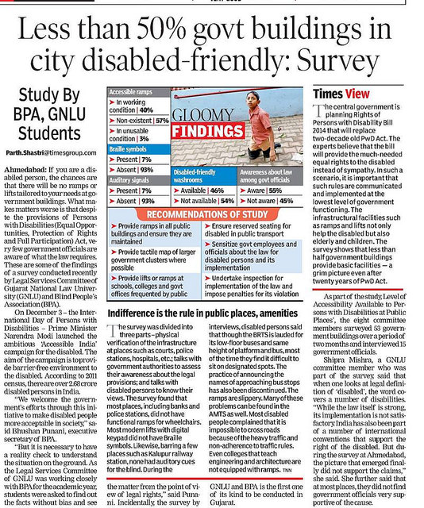
- Accessible India Campaign Report
The LSC was involved with the Blind Peoples Association, Ahmedabad in making the official report of the Accessible India Campaign, a campaign launched by the Prime Minister’s Office (PMO) to work towards improving infrastructure for a pro-disability environment. The report is now the official report of the Accessible India Campaign.

  - 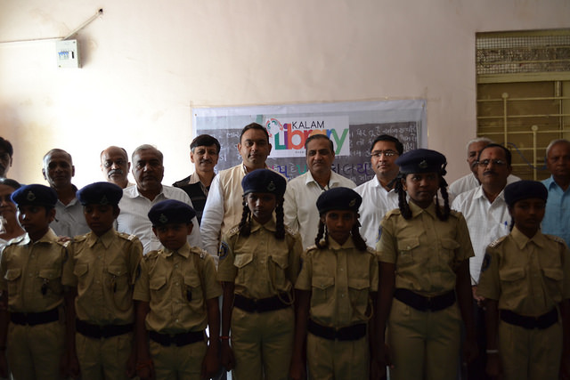

- Kalam Library:
The LSC started a KALAM Library in the village of Koba for underprivileged children. The library was supported by the KALAM Library initiative and the Gram Panchayat, Koba Village. The library and donations will be taken care of by the LSC. The library has already seen a donation of over 200 books. This initiative has also been covered by the newspaper Ahmedabad Mirror in its daily edition of 18th April, 2016.

  - 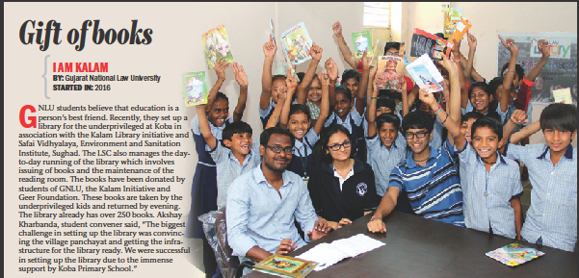

- One Billion Rising
The LSC in association with Action Aid, Ahmedabad launched the Ahmedabad chapter of the global women’s rights movement, the One Billion Rising Campaign on February 14, 2016.
  - 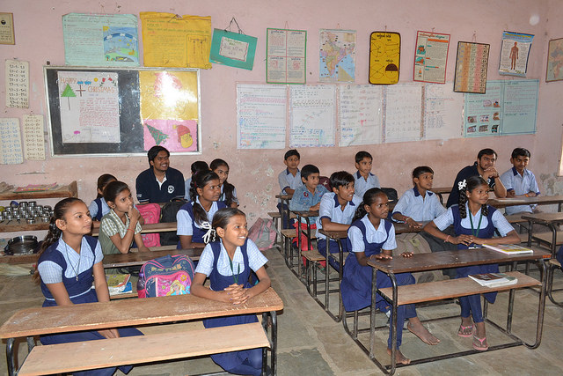

- YUVA Leadership Activity
The LSC in collaboration with YUVA Unstoppable - Ahmedabad Chapter, undertook the Leadership Activity. The initiative involves teaching of general studies and subjects (pertaining to curriculum as set by YUVA Unstoppable which is in consonance with the curriculum approved by the Government of Gujarat). The first day of the initiative saw the participation of LSC members along with Mr. Malav Vyas from Team YUVA and over a hundred primary school children. The event was attended by the Sarpanch of Koba Village, Mr. Yogesh and the Deputy Principal of the school Ms. Kanchan. The event also saw massive support from the teachers and school administration. This is now a regular initiative of the LSC with LSC volunteers holding these every Saturday, 9:45am - 11am at Koba Primary School.

  - 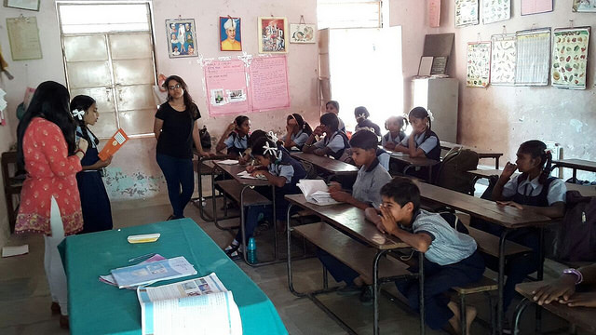
- Vaanchan Saptaah
The Gujarat government started an initiative called ‘Vaanchan Saptaah’ from 14th march 2016 to 19th march 2016 to make reading good books a natural cultural practice in the State. The Legal Services Committee volunteered to implement this fundamental building project in the village school of Koba, Gandhinagar. The student members of the LSC went to the Koba School for the whole week. The children were made to read story books and interact with other students.

- Blind People’s Association
The LSC in association with BPA, Ahmedabad will launch a book on disability laws. The book will provide basic knowledge about disability laws and social policies in India. The LSC will also organize a workshop on disability laws for government officials. Apart from that, a one-day seminar is to be held at Blind People’s Association (BPA). The talks are underway. The final dates will be concluded by September 28, 2016.

- Blood Donation Camp
A Blood Donation Camp was organized on the occasion of GNLU’s 13th Foundation Day, in collaboration with the Indian Red Cross Society-Ahmedabad Chapter on 15th July 2016, Friday. It was held between 12:30 pm- 5:30 pm at the Legal History Museum, Administrative Block. The camp received a thumping response, with over 235 people turning up for the event, out of which 170 could successfully donate for the noble cause.
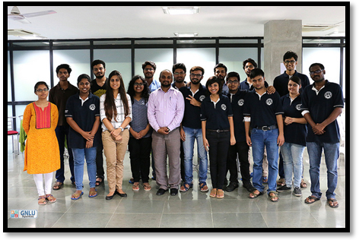

- Make a Difference (MAD), Ahmedabad Recruitment Orientation
Make a Difference is a youth driven, non-profit organisation working to ensure equitable outcomes for children in orphanages and street shelters by helping them in their academics and personal development, by taking regular classes. MAD conducted an orientation for the GNLU students to encourage them to participate in their recruitment drive, to be held later in the semester.

- Activity with the District Development Office (DDO), Ahmedabad:
The LSC worked with the District Development Office (DDO), Ahmedabad in preparing draft schemes undertaken by the District Panchayat from August 20, 2016 to September 04, 2016. The LSC also worked with the DDO on designing a web portal for the effective implementation of the Right to Education (RTE) Act, 2005 from July 15, 2016 to August 20, 2016.

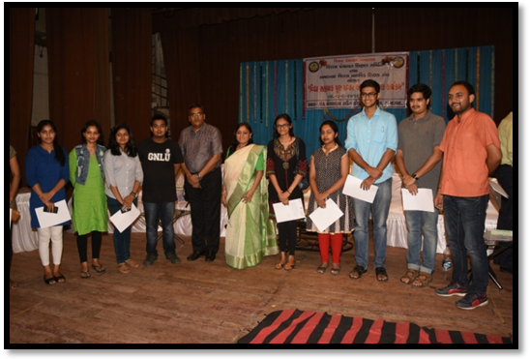

- LSC and SEWA’s visit to Dehgam, Gandhinagar
GNLU-LSC conducted a camp for women in the village as a part of the Legal Aid Clinic initiative at Dahegam, Gandhinagar. This visit was conducted in collaboration with an NGO called SEWA (Self Employed Women's Association), which organises workers to achieve their goals of full employment and self reliance through the strategy of struggle and development. SEWA organizes these close knit meetings with women to provide guidance and help setup self help groups among themselves. The team was successful in registering some grievances which may be taken up as legal cases by the GNLU Legal Aid Clinic, which shall provide legal advice and follow ups, free of charge.
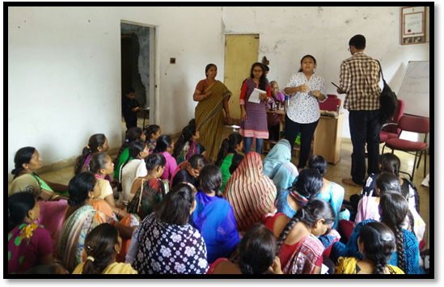

- Kalam Library, Raisan
The GNLU LSC was successful in starting the first library for under privileged children under the Kalam Foundation initiative in the Koba village and it will be launching the second chapter of the same in Raisan by the end of October, 2016.

- Kalam Conclave
The Dr. A.P.J Abdul Kalam Memorial International Youth Conclave on Creating Liveable Planet Earth was conducted on July 26-27, 2016. All the delegates attending this Conclave were identified as Ambassador for liveable Planet and shall work post conclave on voluntary basis to promote the missions of Dr. A.P.J Abdul Kalam and other nation and planet building actions. A contingent of members from the Centre for Law and Society were the part of the conclave. LSC shall in future indulge in the activities pursued by the Foundation.
FUTURE AGENDAS - 2017
- LSC week
  - The GNLU-LSC will be organizing an LSC week in the first week of April, 2017. This week would be dedicated to a number of socio-legal activities which will involve participation of students and faculty of GNLU as well as people from all walks of life.
- 2nd National LSC Interlinking Annual Forum, 2017
  - The 2nd National Interlinking Annual Forum on Access to Legal Services, 2017 is based on four themes, Prisoner’s Rights and Reform, Juvenile Justice, Rural Sanitation and Disability and Mental Health. The forum is scheduled to be held on April 08-09, 2017.
- Consumer Courts Litigation
  - The LSC plans to take up cases of the common man in consumer courts across Ahmedabad-Gandhinagar in association with Consumer Education and Research Centre (CERC), Ahmedabad. To spearhead the cause, a team of the committee shall start its initial phase of the same by visiting the Grahak Nyaylaya in Gota, Ahmedabad. The same shall be done as a free legal aid service for aggrieved consumers.
- YUVA Unstoppable
  - The LSC will be involved with YUVA in the identification and improvisation of sanitation and basic hygiene in municipal schools in Ahmedabad and Gandhinagar.

- Blind Peoples Association, Ahmedabad:
- A PIL to be drafted and submitted in the High Court of Gujarat in relation to the devotees at Mira Datar Dargah in Mehsana with the Blind Peoples Association, Ahmedabad. The PIL is to be filed in accordance with the protection provided to such persons in the Rights of Persons with Disabilities Act, 2016. The LSC also plans to carry out the following with the BPA – (i) In continuation of the survey on Section 12 (1) (c) of the Right to Education Act conducted in November, 2016, the LSC plans to conduct the survey full-fledged in 20 schools across Ahmedabad by the end of May 2018 and (ii) Sensitization seminars relating to disability and mental health for school principals and administrators by means of a talk-series.

- Environment and Sanitation Institute, Sughad:
- Awareness and fund-raising with the Environment and Sanitation Institute, Sughad for rural sanitation and hygiene. LSC volunteers and members will work with ESI throughout the year to build accessible toilets and spread awareness about the ill effects of open defecation and its implications on general hygiene.

- Kalam Foundation:
- In its continued effort to make education more accessible to rural children, the LSC plans to set up atleast 2 more LSC-Kalam libraries in Gandhinagar district by the end of May, 2018 after the setting up of the 1st library at Koba on January 18, 2016. The LSC also plans to start an exclusive LSC mobile library for nearby villages by April end.

- For details of the activities of the LSC, GNLU and any future associations, kindly reach us at –
+918128650808 - Mr. Saurabh Anand, Centre Director, Centre for Law and Society (GCLS)
+919586883240 - Mr. Akshay Kharbanda, Student Convener, Legal Services Committee (LSC)
E-mail - legalservices@gnlu.ac.in

To know more about us, please have a look at our social media handles run entirely by student members –
- Facebook Page: https://www.facebook.com/TheLegalServicesCommittee/
- Blog Handle: https://gnlulsc.wordpress.com
- Twitter Handle: https://twitter.com/LscGnlu?lang=en
- Flickr Account: https://www.flickr.com/photos/140404394@N02/albums

Legal Services Committee 2016-17
“Awareness, Assertion, Action”

Section 8-State Authority to act in coordination with other agencies, etc., and be subject to directions given by Central Authority- In the discharge of its functions the State Authority shall appropriately act in coordination with other governmental agencies, non-governmental voluntary social service institutions, universities and other bodies engaged in the work of promoting the cause of legal services to the poor and shall also be guided by such directions as the Central Authority may give to it in writing. Section 11- District Authority to act in coordination with other agencies and be subject to directions given by the Central Authority, etc.- In the discharge of its functions under this act, the District Authority shall, wherever appropriate, act in coordination with other governmental and non-governmental institutions, universities and others engaged in the work of promoting the cause of legal services to the poor and shall also be guided by such directions as the Central Authority or the State Authority may give to it in writing.

